

S71 MONTHLY REPORT

**1920 SCHEDULE C**

Budget & Reporting

Budget & Treasury Office

1920 SCHEDULE C

**Table of Contents**

**REPORT ON S71 OF THE MFMA FOR THE PERIOD ENDING 29 FEBRUARY 2020** 3

**1.1** **PURPOSE** 3

**1.2 DELIBERATION/DISCUSSION** 4

**1.3** **Resolutions** 5

**1.4** **Monthly Budget Statement Tables** 5

**2.1** **Debtors Analysis** 14

**2.2** **Creditors Analysis** 20

**2.3** **Investment Portfolio Analysis** 20

**2.4** **Allocation and Grant receipts and Expenditure** 22

**2.5** **Councillor and Staff Benefits** 23

**2.6** **Material Variances to the SDBIP** 25

**2.7 Municipal Manager’s Quality’s Certificate** 34

**REPORT ON S71 OF THE MFMA FOR THE PERIOD ENDING 29 FEBRUARY 2020**

* 1. **PURPOSE**

To table the monthly expenditure report in terms of s71 of the MFMA for the period ending 29 February 2020 to Executive Committee.

**LEGISLATIVE FRAMEWORK**

* Local Government: Municipal Finance Management Act, 56 of 2003
* SCM Regulations
* SCM Policy
* Municipal Budget Reporting Regulation
* Division of Revenue Act

**LEGISLATIVE REQUIREMENTS**

In terms of the section 71 of the MFMA the accounting officer of a municipality must by no later than 10 working days after the end of each month submit to the Mayor of the municipality and the relevant provincial treasury a statement in the prescribed format on the state of the municipality’s budget reflecting the following particulars for that month and for the financial year up to the end of that month:

*(a)* Actual revenue, per revenue source;

*(b)* actual borrowings;

*(c)* actual expenditure, per vote;

*(d)* actual capital expenditure, per vote;

*(e)* the amount of any allocations received;

*(f)* actual expenditure on those allocations, excluding expenditure on—

(i) its share of the local government equitable share; and

(ii) allocations exempted by the annual Division of Revenue Act from compliance with this paragraph; and

*(g)* when necessary, an explanation of—

(i) any material variances from the municipality’s projected revenue by source, and from the municipality’s expenditure projections per vote;

(ii) any material variances from the service delivery and budget implementation plan; and

(iii) any remedial or corrective steps taken or to be taken to ensure that projected revenue and expenditure remain within the municipality’s

* 1. **DELIBERATION/DISCUSSION**

The discussion that follows, in terms of MFMA Section 71 above, intends to inform the Executive committee on the progress made thus far in terms of implementing the 2019/2020 budget for the period ending 29 February 2020.

* 1. **Resolutions**

This report will be tabled to Finance and Corporate committee and therefore the resolution will be available once it tabled to council in terms of Sec 52 (d) of the MFMA.

* 1. **Monthly Budget Statement Tables**

**Monthly Budget Statements Summary**

Table C1 below provides a summary of the overall performance in the Municipality and is unpacked in the sections that follow.



**Financial Performance**

Table C2 provides the statement of financial performance by standard classification.



This table assess the revenue by department and then the expenditure for the period ending 29 February 2020. Revenue receipts in February have largely constituted of service charges which is water and sanitation. The overall budgeted revenue cash receipt for the month of February is 2%.

Expenditure by standard classification presents the expenditures by the departments. Water Services department has the largest expenditure for the month of February 2020 as the department responsible for the repairs and maintenance of the municipal assets and also with the largest staff complement, shares the greatest bulk of this budget

Table C3 presents the same information as the table above, the difference being that it’s by Municipal vote.



**Statement of financial Performance**

This schedule provides information on the planned revenue and operational expenditures against the actual results for the period ending 29 February 2020.



**Capital Expenditure**

Table C5 below reports on the capital expenditures by departments (municipal vote) and also by standard classification. The bottom part of the schedule looks at the funding sources of the capital projects.



As alluded to above, the capital expenditure programme for the month ending 29 February was R15, 5m of capital expenditure against year to date budget.

The chart below presents a high level analysis of YTD capital expenditure budget against the YTD actual expenditure.

**Chart 1: 2019/2020 CAPEX YTD BUDGET & YTD ACTUAL**

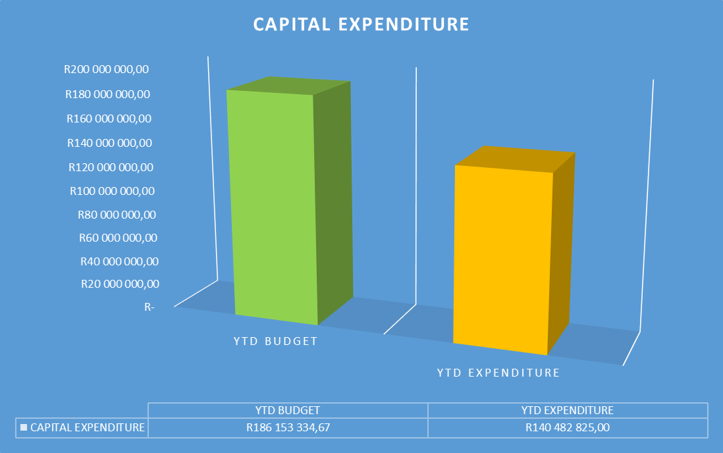

As at 29 February 2020, the year to date actual expenditure was R140, 4million against a YTD budget of R186, 1million. In monetary terms, these figures represent 75% per cent performance against the capital development programme as at 29 February 2020.

Table C6 displays the financial position of the municipality as at 31 January 2019.



Table C7 below display the Cash Flow Statement for the period ending 29 February 2020.



**PART 2 – SUPPORTING DOCUMENTATION**

* 1. **Debtors Analysis**

The table presented below summarises the Debtors Age Analysis as at 29 February 2020.

**Table 2.1.1: Debtors Age Analysis by Income Source**



**Chart 2: Debtors Age Analysis by Customer Group**

The information presented in the chart above ranks total debt owed to the municipality from highest to the lowest,

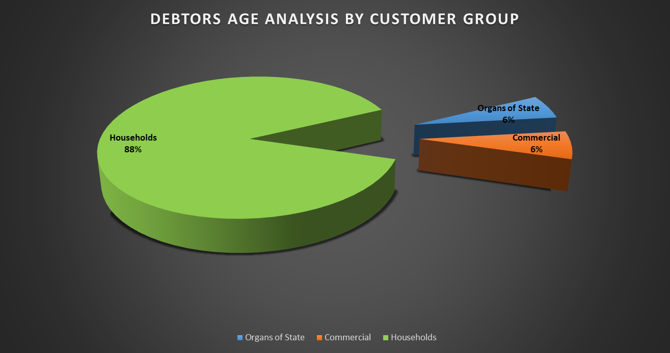

* Households: 88%
* Government 6%
* Business 6%

The chart above shows that for each debtor type the amounts owing to the municipality have increased on a year to year basis.

The table that follows below unpacks the revenue receipts per Local Municipality in the District

**REVENUE RECEIPTS PER AREA**

|  |  |  |
| --- | --- | --- |
| AREA | AMOUNT |  |
| **FEBRUARY 2020** | **JANUARY 2020** |
| Unallocated receipts | R 172 498,46 | 3% | 52% |
| Bhongweni | R 16 086,45 | 0% | 1% |
| Shayamoya | R 29 252,36 | 1% | 1% |
| Kokstad | R 3 375 045,76 | 67% | 28% |
| Ixopo | R 277 061,38 | 9% | 9% |
| NDZ | R 668 066,58 | 13% | 8% |
| Umzimkulu | R 481 275,89 | 10% | 3% |
| Fairview | R 163,00 | 0% | 0% |
| TOTAL RECEIPTS INCL VAT | **R 5 019 286,88** | 100% | 100% |

The table above presents the cash receipts from consumer debtors in each of the detailed areas as well as the comparative receipts for the previous month. The total cash collected for February 2020 is R5million

**BILLING VS COLLECTION FOR JANUARY AND FEBRUARY 2020**

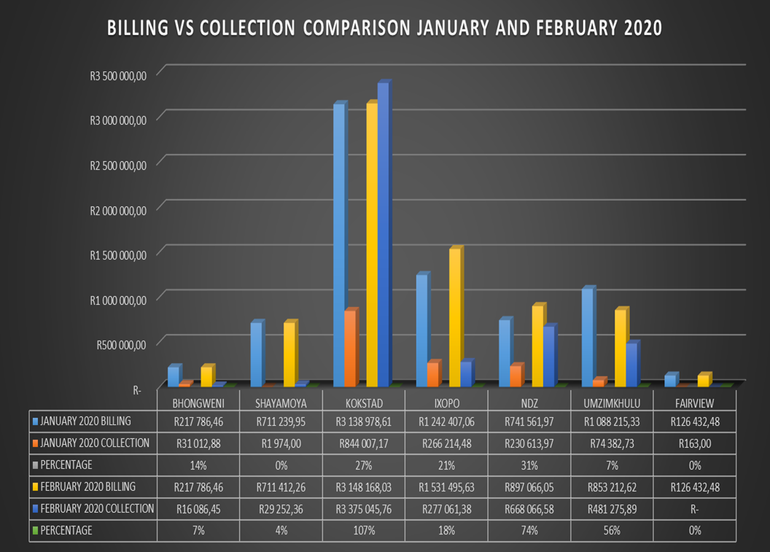

**BILLING VS COLLECTION TREND FOR FEBRUARY 2020**

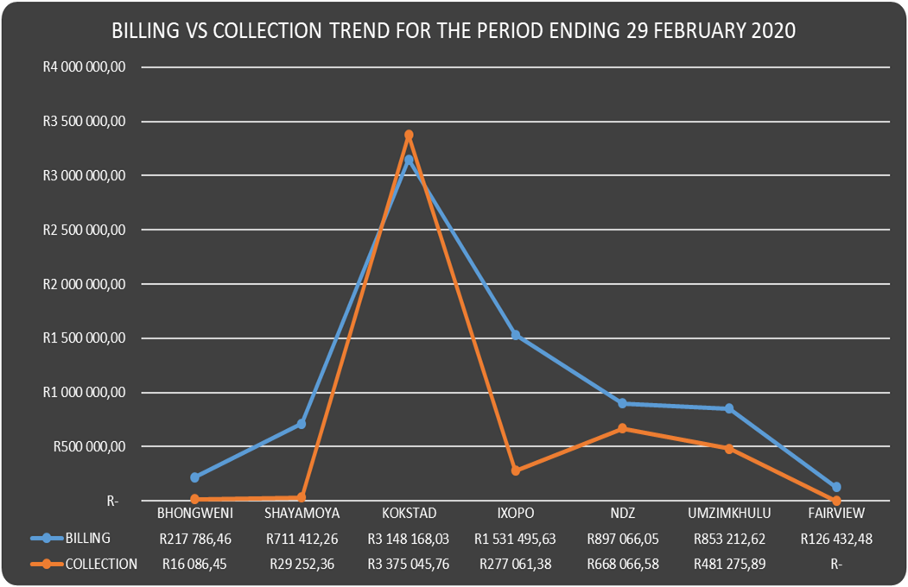

**Debtors age analysis per service**

The municipality’s total outstanding debtors amounted to R 206 644 228 as at 31 January 2020 compared with the R 204 301 789 as at 31 January 2020. Current debt represent 4% of the total outstanding debt compared with the 5% of January 2020; 30 days and older debt 4% compared with the 3% for January 2020; 60 days and older debt 3% compared with the 3% of January 2020; and 90 days 3% compared with the 3% of January 2020; 120 days to History and older 87% compared with the 84% for January 2020.

Current debt increased with R 2,342,439 to R 206,644,228 compared with the R 204,301,789 as at 31 January 2020; 30 days + debt Increased with R 313,518; 60 days + Decreased with R 838,880; 90 days + debt Increased with R 108,712 and 120 + days and older debt as at January 2020 has increased with R 3,981,094 to R 179,633,266 compared with the R 175,652,172 as at 31 January 2020.

**Debtors age analysis per debtor type**

Business debtors owes the municipality R 12,785,662 (6%); Municipal debtors R 957,818 (0.01%); domestic debtors R 150,500,534 (73%); Government accounts R 10,073,186 (5%); Indigent debtors R 28,838,862 (14%) and other debtors R 3,488,166 (2%) of the total outstanding debt of R 206,644,228. Furthermore most of the domestic debt and other debt will be irrecoverable and most probably will also have to be written off.

* 1. **Creditors Analysis**

Table SC presents the aged creditors as at 29 February 2020.



* 1. **Investment Portfolio Analysis**

The following information presents the cash at bank and short term investments balances broken down per investment type as at 29 February 2020.The closing cash and cash equivalents as at the end of January 2020 was R88, 7million refer to the table below for cash and cash equivalent register for more detail on the municipality’s cash position

**Cash and Bank Balances (Investments)**

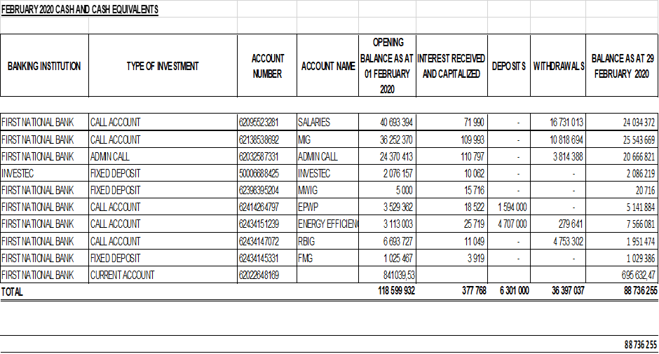

* 1. **Allocation and Grant receipts and Expenditure**

Table SC 6 displays information relating to grant receipts.



It is clear from the chart above that the bulk of the grants received by the municipality are from the National Treasury.

Table SC7 track the expenditure on Conditional grant funding.



* 1. **Councillor and Staff Benefits**

Table SC8 presents the expenditure of councillor and staff benefits at 29 February 2020.



* 1. **Material Variances to the SDBIP**

The following section analyses material variances between the actual targets as at 29 February 2020 and the budget for the same period. This report analyses each major component under following headings;

* Revenue by Source
* Operational Expenditure by Type, and
* Capital Expenditure
* Financial Position
* Cash Flows

**REVENUE**

The chart displays a comparison between the 201920 financial year revenue budget and the performance against this budget as depicted in the form of Year to date (YTD) Actual figures. It should be emphasised that the information presented relates to “performance” rather than “cash movements” in terms of the revenue items listed below. This accounting principle relating to municipal performance is best illustrated in the analysis that follows.

**Chart 3: Revenue Analysis**

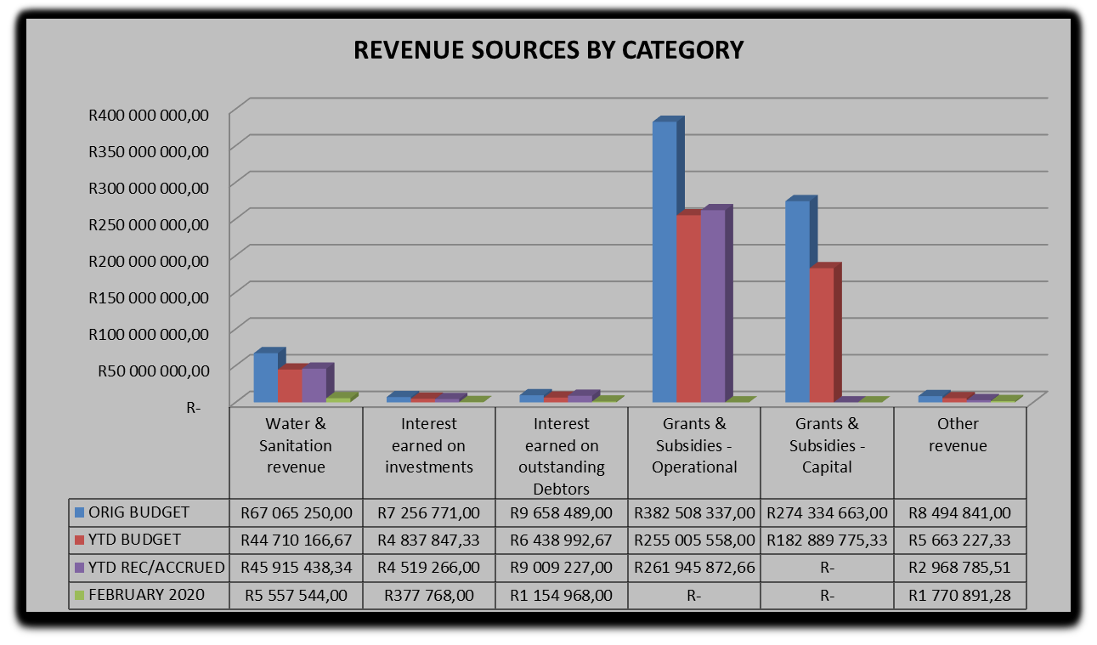

**Water & Sanitation Charges**

The year to date **actual** water & sanitation charges **(billing)** as at 29 February 2020 was R45, 9million against a year to date **budget** of R44, 7million.

**Interest Earned on External Investments**

The year to date actual on interest earned on external investments as at 29 February 2020 is R4, 5m against year to date budget of R5, 6million.

**Transfers Recognised – Operational**

Three operational grants received for the month of February 2020.Namely

* Expanded Public Works Programme - R 1 594 000
* Rural Road Asset Management Systems Grant - R 707 000
* Energy Efficiency and Demand Management Grant – R 4 000 000

**Transfers Recognised – Capital**

The year to date actual R140, 4million (against a YTD budget of R186, 1million) represent the conditions met in capital expenditures against the conditional grant allocation received. This amount represents 75% performance in Conditional Capital grant funding expenditures.

No Capital grants received for the month of February 2020

**Other Revenue**

The YTD performance of other revenue is R 2, 9m against YTD budget of R5, 6m.

**OPERATIONAL EXPENDITURE**

The chart below presents the YTD operational expenditure movements against the YTD budgets. An analysis of each expenditure line item category is discussed below.

**Chart 4: 2019/20 financial year opex**

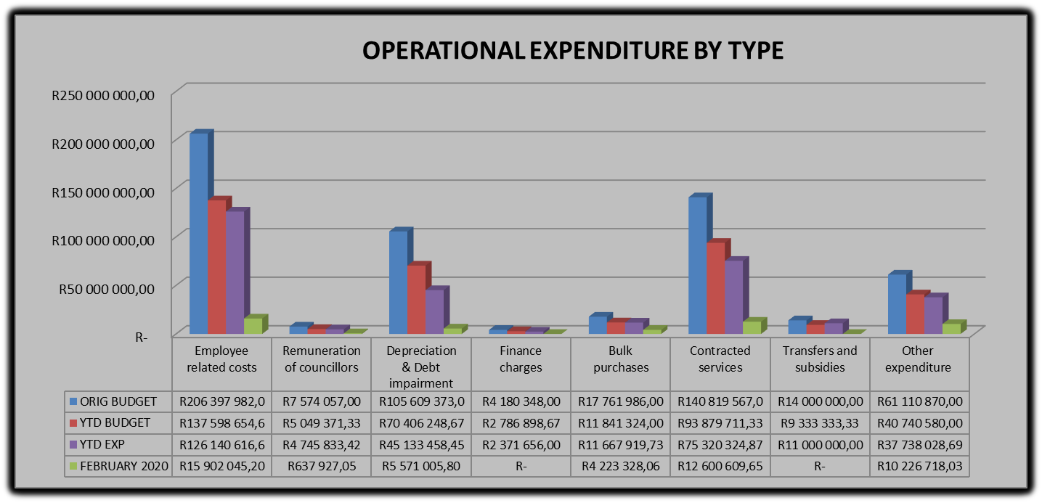

**Employee Related Costs**

The YTD budget for employee related costs is R137, 1million against a YTD actual of R126, 1million representing 92 per cent of actual expenditure. Employee related costs are still within budget.

**Remuneration of Councillors**

The remuneration of councillor’s expenditure as at 29 February 2020 was R4, 7million against a year to budget of R5million.

**Finance Charges**

As at third quarter, the finance charges budget has been overspent by 1%

**Bulk Purchases**

The expenditure on Bulk Water purchases for the month of February 2020 is R4, 2million, when comparing to the year to date actual of R11, 6million against year to budget of R 11, 8million which is at 99 per cent expenditure in the month of February 2020.

**Other Expenditure**

The year to date actual is R37, 3million against year to date budget of R 36, 3million.

**Performance assessment**

The Performance Assessment Report will be available on the second quarter of 2019/2020 financial year in terms of mid-term performance assessment in accordance with the Municipal Finance Management Act.

**Actual and revised targets for cash receipts**

**Parent Municipal financial performance**



**Capital Expenditure Trend**



**CAPITAL EXPENDITURE MONTHLY TREND**

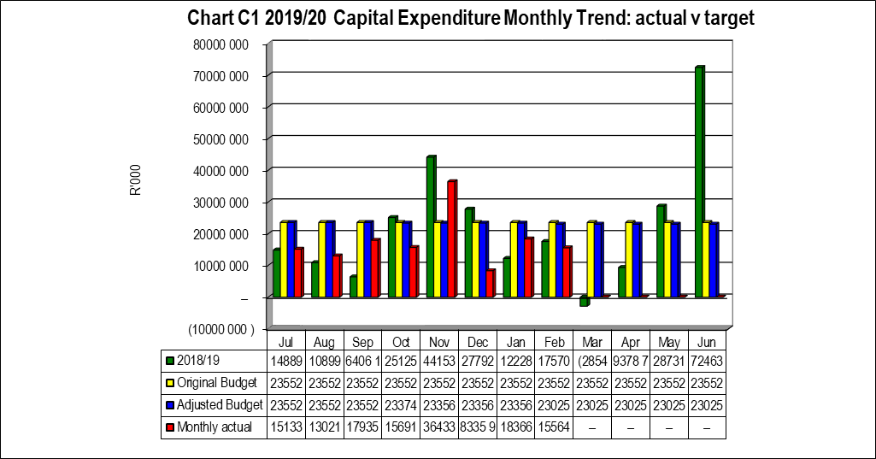

**Capital Expenditure on New Assets by Asset Class**



**2.7 Municipal Manager’s Quality’s Certificate**

Quality Certificate

I, Adelaide Nomnandi Dlamini, the Municipal Manager of Harry Gwala District Municipality, hereby certify that-

* The monthly budget statement

For the month of February 2020 has been prepared in accordance with the Municipal Finance Management Act and regulations made under that Act.

Print name: Adelaide Nomnandi Dlamini

Municipal Manager of: Harry Gwala District Municipality

Signed____________________

Date______________________